Sistemas Informáticos (Computer Systems)
Unit 03. Activities 02



Authors: Sergi García, Alfredo Oltra
Updated October 2023

Unit 03. Activities 02

Exercise 01
A system has the following resources: a CPU, two disks (DISC1, DISC2) and a printer (PRN). There are two types of process according to the needs of resource utilization:
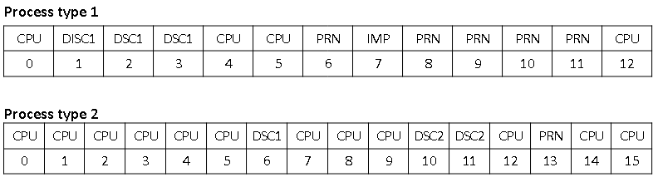
Assuming that the system is running a process of each type, calculate the CPU usage, the average system return time and the waiting time for each job with the following CPU planning algorithms:
- FCFS.
- Round-Robin with quantum=1.
Suppose that the rest of the queues are managed with a FCFS algorithm and that the first process in this system is type 1.

In your solution, you must provide those elements:
A) A table similar to this:
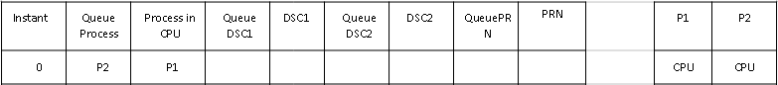
B) These values calculated when process ends:
- P1 Return time:
- P2 Return time:
- Mean return time:
- P1 queue waiting time:
- P2 queue waiting time:
- CPU usage:

